
MEKDEL AMBA UNIVERSITY
COLLAGE OF COMPUTING AND INFORMATICS DEPARTMENT OF SOFTWARE ENGINEERING
COURSE TITLE:SOFTWARE DESGIN AND ARCHITECTURE
COURSE CODE:SEng5232
PROJECT TITLE:ONLINE DISTANCE EDUCATION MANAGEMENT SYSTEM FOR MEKDELA AMBA UNIVERSITY
GROUP MEMBERS:
Name | ID | SEX
PETROSE Tsibika | 1602195 | M
YESHEMEBET MOLLA | 1601323 | F
DERESE Jobire | 1600416 | M

SUBMITTED TO:DESTAYE
SUBMITTED BY :GROUP 6
TULU AWULIA ETHIOPIA

Abstract
This Software Design Document (SDD) presents the architectural and detailed design of the Mekdela Amba University Online Distance Education Management System (MAU CDE MGT System). The primary objective of the system is to digitize and streamline the university's distance education processes, including student registration, course enrollment, assessment management, and grade recording. The design utilizes a robust Relational Database Management System (RDBMS) to maintain data integrity and security. By employing a three-tier deployment architecture involving a client interface, application server, and database server, the system ensures high availability and scalability for students and staff. The document details the Entity-Relationship Diagrams (ERDs), deployment configurations, and system environments necessary for a successful implementation.

Acknowledgement
First and foremost, I would like to express my deepest gratitude to Mekdela Amba University (MAU) for providing the academic environment and resources necessary to undertake this project. I am particularly grateful to the Department of Software Engineering for their continuous guidance and technical support throughout the development of this Software Design Document (SDD).
I would also like to extend my sincere thanks to my instructor and advisor for their invaluable insights and feedback, which significantly improved the quality of the system’s architecture and database design.
Finally, I want to thank my family, especially my mother, for her unwavering emotional support and encouragement. I also appreciate my classmates and peers for their collaborative spirit and brainstorming sessions that helped in refining the MAU CDE MGT System.

TABLE OF CONTENTS

UNIT 1: INTRODUCTION .................................................................... 1
1.1 Purpose ..................................................................................................... 1
1.2 Scope ........................................................................................................ 1
1.3 Overview ................................................................................................... 3
1.4 Intended Users ........................................................................................... 3
1.5 Reference Material ...................................................................................... 4
1.6 Definitions, Abbreviations, and Acronyms ..................................................... 4

UNIT 2: SYSTEM OVERVIEW AND CONSTRAINTS ........................ 5
2.1 System Overview ........................................................................................ 5
2.2 Constraints ................................................................................................. 6

UNIT 3: QUALITY ATTRIBUTE SCENARIOS AND TACTICS ............ 7
3.1 Quality Attribute Scenarios .......................................................................... 7
3.2 Tactic Selection .......................................................................................... 8

UNIT 4: SYSTEM ARCHITECTURE ................................................... 9
4.1 Architectural Design (Layered Pattern) ........................................................ 9
4.2 Module View (Class Decomposition) ............................................................ 10
4.3 Component and Connector View ................................................. 11
4.4 Architecture Diagrams ................................................................................ 12
4.4.1 High-Level Architecture Diagram ....................................................... 13
4.4.2 Component Diagram .......................................................................... 14
4.4.3 Subsystem Interaction (Sequence Diagram) ....................................... 15
4.5 Allocation View (Deployment) ..................................................................... 15
4.5.1 Deployment Model ............................................................................. 16
4.5.2 Description of Elements ..................................................................... 16
4.6 Design Rationales ...................................................................................... 18

UNIT 5: DATA DESIGN ..................................................................... 21
5.1 Data Description ........................................................................................ 21
5.2 Data Dictionary ........................................................................................ 21

UNIT 6: COMPONENT DESIGN ........................................................ 26
6.1 Use Case Diagram and Descriptions ............................................................ 27
6.2 Deployment Detail ...................................................................................... 31
6.3 Environment Description (HW/SW Requirements) ........................................ 32

UNIT 7: REQUIREMENTS MATRIX ................................................... 34

UNIT 8: CONCLUSION ..................................................................... 37

LIST OF TABLES
Table 3.1: Tactic Selection for Quality Attributes ........................................ 8
Table 4.1: Architecture Design Rationale Summary ..................................... 20
Table 5.2: Object and Entity Dictionary ....................................................... 22
Table 5.3: Database Schema Definitions .....................................................23
Table 7.1: Requirements Traceability Matrix ................................................ 34

LIST OF FIGURES
Figure 4.2: UML Class Diagram
Figure 4.4.1: High-Level 4-Layer System Architecture
Figure 4.4.2: COMPONENT Diagram
Figure 4.4.3: UML Sequence Diagram
Figure 4.5: Physical Deployment Diagram
Figure 5.1: Data Flow Diagram (DFD)
Figure 5.2: Entity-Relationship Diagram (ERD)
Figure 6.1: System Use Case Diagram

UNIT 1: INTRODUCTION

1.1 Purpose
The purpose of this Software Design Document (SDD) is to formally identify and describe the software architecture and system design of the Online Distance Education Management System. It serves as a comprehensive technical guide for the development team and provides a clear blueprint for the system's structural implementation.
This document is intended for project stakeholders, software architects, and developers, ensuring that all parties have a shared understanding of how the system will be built to meet its functional and non-functional requirements.

1.2 Scope
The Online Distance Education Management System is a comprehensive software platform designed to digitize and streamline the academic operations of the distance education wing at Mekdela Amba University. This system serves as the primary digital interface for remote learning, bridging the gap between the physical campus and students across various regions.

Description
The software encompasses a web-based portal that manages the end-to-end student lifecycle, including registration, secure access to course modules, assignment submission portals, and automated grading systems. It is designed to operate under diverse network conditions to ensure inclusivity for all students.

Goals and Objectives
- Centralization: To provide a single, unified repository for all course materials and academic records.
- Accessibility: To allow students to engage with their education at any time and from any location, reducing the need for physical travel to the university.
- Efficiency: To automate administrative tasks such as enrollment verification and grade calculation, reducing manual errors and processing time.
- Engagement: To facilitate structured communication between instructors and students through integrated messaging and feedback tools.

Benefits
- For Students: Offers a flexible learning schedule and immediate access to academic resources and performance tracking.
- For Instructors: Provides organized tools for content distribution and streamlined grading workflows.
- For the University: Enhances the institution's reach and reputation by providing modern, high-quality distance learning infrastructure.

1.3 Overview
This document provides a comprehensive description of the software architecture and system design for the Online Distance Education Management System. It is organized to guide the reader through the foundational context, technical constraints, and detailed architectural views.
The organization of this document is as follows:
- System Overview and Constraints: Establishes the general functionality, context, and special constraints affecting the design and implementation strategy.
- Quality Attribute Scenarios and Tactics: Details the high-priority non-functional requirements and the specific design decisions (tactics) chosen to address them.
- System Architecture: Presents a high-level decomposition of the system into subsystems, including architectural patterns and various views such as Module, Component and Connector, and Allocation views.
- Data Design: Describes how the information domain is transformed into data structures, including the data dictionary and entity storage.
- Component Design: Provides a systematic look at component functionality using use case diagrams and physical deployment models.
- Requirements Matrix: Provides a cross-reference to trace components and data structures back to the original functional requirements.

1.4 Intended Users
This document is intended for the following stakeholders involved in the development and maintenance of the Online Distance Education Management System:
- Software Developers and Engineers: To guide the implementation of the system’s modules, data structures, and algorithms.
- System Architects: To review and validate the structural decomposition, architectural patterns, and design trade-offs.
- Database Administrators: To understand the data entities, relationships, and schema required for the university's information domain.
- Project Managers and Academic Stakeholders at Mekdela Amba University: To ensure the technical design aligns with the project goals, constraints, and university standards.
- Quality Assurance (QA) and Testing Teams: To use as a reference for creating test plans based on the quality attribute scenarios and functional requirements.

1.5 Reference Material
The development of this Software Design Document (SDD) is guided by the following academic and technical references:
- Sommerville, I. (2015). Software Engineering (10th Edition). Pearson Education. (Used for defining the system architecture and Software Development Life Cycle (SDLC) processes).
- Elmasri, R., & Navathe, S. B. (2015). Fundamentals of Database Systems (7th Edition). Pearson. (Applied for Entity-Relationship modeling and database normalization).
- Pressman, R. S., & Maxim, B. R. (2020). Software Engineering: A Practitioner's Approach (9th Edition). McGraw-Hill Education.
- Fowler, M. (2003). UML Distilled: A Brief Guide to the Standard Object Modeling Language (3rd Edition). Addison-Wesley Professional. (Reference for Deployment and Class Diagrams).
- Mekdela Amba University (MAU). Academic Policy and Online Education Standards (2026).
- Official Documentation of Draw.io (diagrams.net). (Reference for standard UML modeling notation).

1.6 Definitions, Abbreviations, and Acronyms
The following terms, acronyms, and abbreviations are used throughout this Software Design Document (SDD) to ensure a consistent understanding among all stakeholders:
- MAU: Mekdela Amba University, the primary institution for which this system is being developed.
- SDD: Software Design Document; the technical document describing the architecture and design of the software.
- SRS: Software Requirements Specification; the document that lists the requirements the system must satisfy.
- LMS: Learning Management System; a software application for the administration, documentation, and delivery of educational courses.
- UI/UX: User Interface and User Experience; referring to the visual elements and the overall experience a student or instructor has when using the system.
- OO: Object-Oriented; a design approach based on the concept of "objects" which contain data and code.
- DFD: Data Flow Diagram; a visual representation of the flow of data through the management system.
- ERD: Entity-Relationship Diagram; a diagram that shows the relationships between major data entities like Students, Courses, and Instructors.
- PDL: Procedural Description Language; a language used to describe algorithms in a format that resembles programming code.
- Tactic: A design decision that affects the achievement of a quality attribute response, such as using a "spare" for fault recovery.

Unit 2. SYSTEM OVERVIEW AND CONSTRAINTS

2.1 System Overview
The Online Distance Education Management System is designed to provide a robust digital infrastructure for Mekdela Amba University (MAU), specifically tailored to meet the needs of its growing distance learning population. The system functions as a comprehensive virtual campus, integrating administrative, academic, and interactive tools into a single accessible platform.
Functionality The system's core functionality is centered around three primary user groups:
- Students: Can register for courses, download modular learning materials, submit assignments electronically, and view their academic progress through a personalized dashboard.
- Instructors: Are provided with tools to upload course content, manage student submissions, provide feedback, and record grades securely.
- Administrators: Manage the overall system health, handle faculty and student account provisioning, and oversee the integrity of the university's academic data.
Context In the context of MAU's expansion, this project addresses the logistical challenges of reaching students in geographically dispersed locations. It operates within the university's existing IT ecosystem, ensuring that remote academic activities are synchronized with central registrar records.
Design The design follows a Client-Server model to ensure that resources are managed centrally while remaining accessible via web and mobile interfaces. The architecture is modular, allowing for future updates—such as adding video conferencing or advanced library features—without disrupting existing core services. This design prioritizes a low-bandwidth user interface to accommodate students in areas with limited internet connectivity.

2.2. Constraints
This section outlines the specific limitations and requirements that govern the development of the Online Distance Education Management System for Mekdela Amba University. These constraints ensure the system is developed within the boundaries of the university's technical and organizational realities.
- Design and Implementation Strategy: The system must prioritize a mobile-first and low-bandwidth design to ensure accessibility for students in remote areas with unstable internet connections.
- Development Tools: The implementation is constrained to the use of Java-based technologies for backend services (such as Java Socket programming for specific communication tasks) and the Wix platform or standard web frameworks for the front-end to ensure ease of maintenance by the university’s IT staff.
- Team Structure: The development team consists primarily of students and faculty from the Computer Science/Software Engineering department at Mekdela Amba University, necessitating a highly collaborative and well-documented workflow.
- Schedule: The project must be completed and ready for deployment within the 2026 academic calendar, specifically targeting a full launch by the end of the second semester.
- Legacy Code and Integration: The system must be capable of integrating with existing Microsoft Excel-based student records or older registrar databases currently used by the university to ensure data continuity.
- Security and Legal: The software must comply with national data privacy standards and university policies regarding the storage of student grades and personal identification.

Unit 3. QUALITY ATTRIBUTE SCENARIOS AND TACTIC SELECTION

3.1. Quality Attribute Scenarios
Based on the high-priority non-functional requirements for the Mekdela Amba University (MAU) Online Distance Education Management System, the following five quality attribute scenarios have been defined:
- Availability: A student attempts to download a course module during peak hours, and the system must remain operational 99.9% of the time, even if one server node fails.
- Performance: When a student submits a final assignment file, the system must process the upload and provide a "Success" confirmation within 3 seconds under normal network conditions.
- Security: An unauthorized user attempts to access the instructor's grading dashboard; the system must block the access and log the attempt within 1 second to maintain data integrity.
- Scalability: During the final exam week, the system experiences a 500% increase in concurrent users (e.g., from 1,000 to 5,000 students); the system must automatically scale resources to maintain a standard response time.
- Usability: A first-time distance education student logs into the portal to find their registered courses; the user should be able to navigate to the "Course Modules" section in no more than three clicks.

3.2. Tactic Selection
The following table outlines the specific design decisions (tactics) chosen to address the high-priority quality attributes for the Mekdela Amba University Online Distance Education Management System.
Quality Attribute | Design Concern | Tactic Selected | Rationale
QA-1: Availability | Fault Recovery | Spare (Redundancy) | Ensures that if the primary server hosting course modules fails, a secondary "spare" server can take over to maintain student access.
QA-2: Performance | Resource Demand | Manage Sampling Rate / Caching | By caching frequently accessed PDFs and video modules, the system reduces the load on the database and speeds up response times for students.
QA-3: Security | Resisting Attacks | Authenticate Users / Limit Access | Protects sensitive student grades and exam data by ensuring only verified instructors and admins can access specific backend modules.
QA-4: Scalability | Resource Management | Horizontal Scaling | Allows the system to add more virtual server instances during high-traffic periods, such as final exam weeks, to prevent system crashes.
QA-5: Usability | Runtime Performance | Self-Describing UI / Consistency | Minimizes user error and learning time by using a consistent layout across all modules, allowing students to find materials with minimal clicks.

Unit 4: Architectural Design
4.1. Architectural Design
The architectural design of the Online Distance Education Management System follows a Layered Architectural Pattern. This pattern organizes the system into distinct layers based on their responsibilities, ensuring that the user interface, business logic, and data management remain decoupled. This structure is essential for Mekdela Amba University to ensure that the system is both maintainable and capable of evolving as institutional needs grow.

Key Architectural Components:
- Partitioning of Subsystems:
➢Presentation Layer (UI): Manages user interactions for students, instructors, and registrars.
➢Application Layer (Business Logic): Handles core academic processes, such as enrollment validation, grade calculation, and course distribution.
➢Data Layer (Persistence): Manages the retrieval and storage of academic information.
- Interconnection of Subsystems:
➢The system utilizes a centralized Data Repository model where all subsystems (Registration, Assessment, Grading) interact with a unified database to maintain "a single version of truth" for student records.
- Architectural Pattern Rationale:
➢The Layered Pattern was selected because it allows for the independent development and testing of each layer. For example, the user interface can be updated to support mobile devices without requiring modifications to the underlying database schema.
This high-level view serves as the blueprint for the more detailed module and component views that follow in this document

4.2 Module View
The Module View provides a static decomposition of the Online Distance Education Management System into manageable units of implementation. This view is essential for developers as it defines the responsibilities of each software unit and their internal structures.

Structural Decomposition
The system is partitioned into high-level modules, each encapsulated to handle a specific domain of the university's academic workflow:
- User Management Module: Manages the identity, authentication, and authorization of students, instructors, and registrars. It implements security tactics like password hashing and input validation.
- Course & Content Module: Responsible for the lifecycle of educational materials, including the storage and retrieval of course modules and instructional videos.

- Enrollment & Registration Module: Handles the logic for student course selection, learning center assignment, and prerequisite verification.
- Assessment Engine: Manages the generation, submission, and automated grading of assignments and examinations.
- Reporting & Analytics Module: Aggregates data to produce transcripts for students and performance metrics for the university administration.
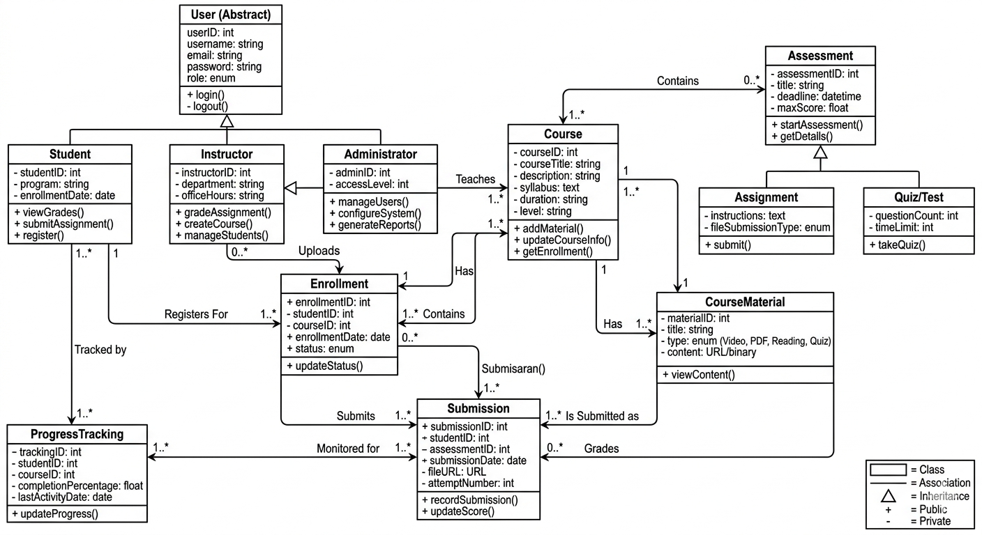
Figure 4.2Class diagram

4.3 Component and Connector View
This view describes the runtime behavior of the system, focusing on the executing components and the communication paths (connectors) between them.

Major Executing Components
- User Interface (UI) Components: Executing in the client's web browser, responsible for capturing user events.
- Controller/Service Components: Backend Java components that manage the application flow and execute business rules.
- Database Connector (JDBC/Socket): The active link that facilitates data retrieval and persistence between the application logic and the database.
- Authentication Service: A specialized component that validates credentials during the login sequence.

Component Interaction (Sequence Diagram)
To illustrate how these components interact at runtime, a Sequence Diagram for a core use case (e.g., Student Enrollment or Assignment Submission) is used.
- Connectors: The connectors in this view are synchronous messages (represented by solid arrows) where one component calls a method on another and waits for a response.
- Interaction Flow: 1. The Student triggers a request via the UI. 2. The UI Component sends a request connector to the System Controller. 3. The Controller interacts with the Database Component to verify prerequisites. 4. The Database returns the status, and the Controller sends a confirmation back to the UI to update the user's view.
Figure4.3 Sequence diagram

4.4 Architecture Diagrams
This section presents the visual representation of the system’s architecture to provide a clear understanding of its structural and behavioral design.

1. High-Level Architecture Diagram (From Section 4.1)
This diagram illustrates the 4-Layered Architecture used in the system, showing the logical separation between the user interface and the data storage.
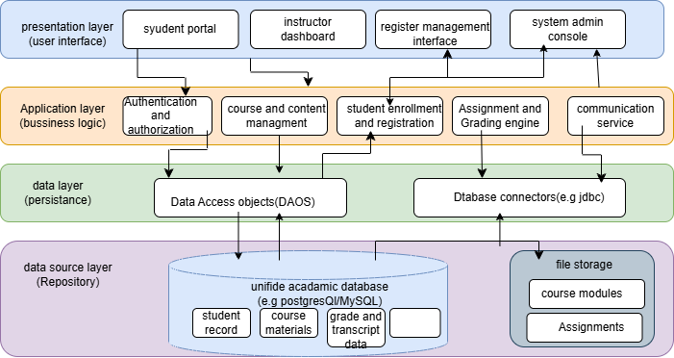
4.4.1 high level architecture diagram

2. Component Diagram (From Section 4.3)
This diagram depicts the runtime components (like the Web Server, Enrollment Controller, and Database Connector) and the interfaces that connect them.
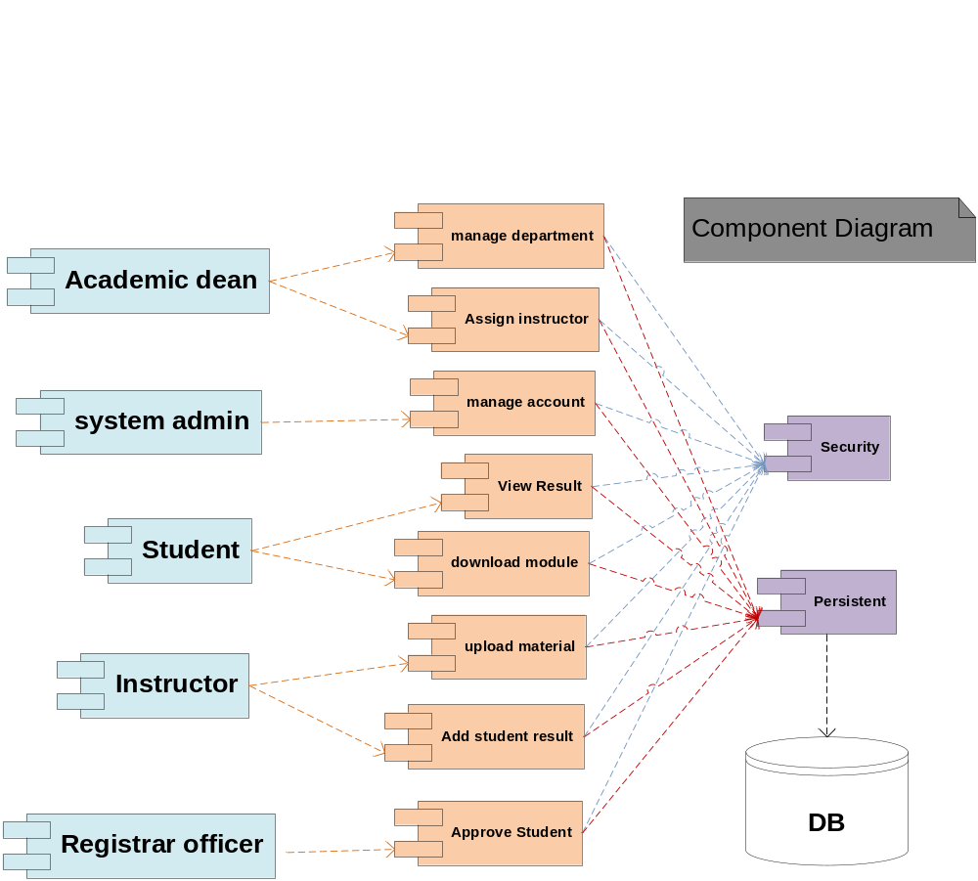figure 4.4.2 component diagram

3. Subsystem Interaction Diagram (From Section 4.3)
This Sequence Diagram demonstrates the interaction between different subsystems during a specific use case, such as a student logging in or registering for a course.
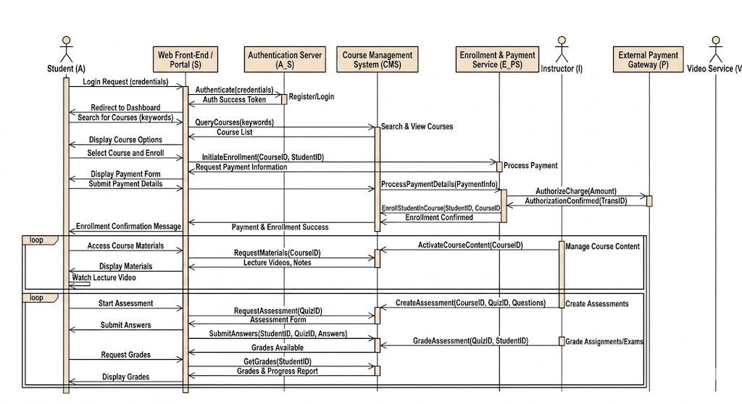
4.4.3 sequence diagram

4.5 Allocation View
This section describes the physical deployment of the system’s software components onto the hardware execution environment. The deployment model follows a multi-tier distributed architecture as shown in the diagram.

4.5.1 Deployment Model
The system is partitioned into a Client-Server structure where the internet acts as the communication medium between the user and the university infrastructure.

4.5.2 Description of Elements
Based on the provided deployment diagram, the major elements are described below:
- Client Machine (Node):
➢Description: This represents the student's or staff's local hardware (e.g., Laptop, Desktop).
➢Installed Components: It contains the Web Browser, which is the primary software used to access the system.
➢Role: It captures user input and sends "Requests" to the server while receiving and displaying "Responses."
- Web Browser Server (Web Server Node):
➢Description: This is the middle-tier server (Application Server) that hosts the system's core logic.
➢Internal Elements: It contains the System Stored logic (Application modules).
➢Role: It processes incoming requests from the Client Machine, communicates with the Database, and prepares the data to be sent back to the user.
- DB Server (Database Node):
➢Description: A dedicated server node responsible for persistence.
➢Internal Elements: It contains the Data Stored (The physical database).
➢Role: It receives data requests from the Web Server, performs search/save operations, and sends the retrieved data back as a response.
- Connectors and Interactions:
➢Internet (Cloud): The backbone that connects all nodes together.
➢Request/Response Paths:
    - The Client Machine sends a Request to the Web Server and receives a Response.
    - The Web Server sends a Request to the DB Server and receives a Response.
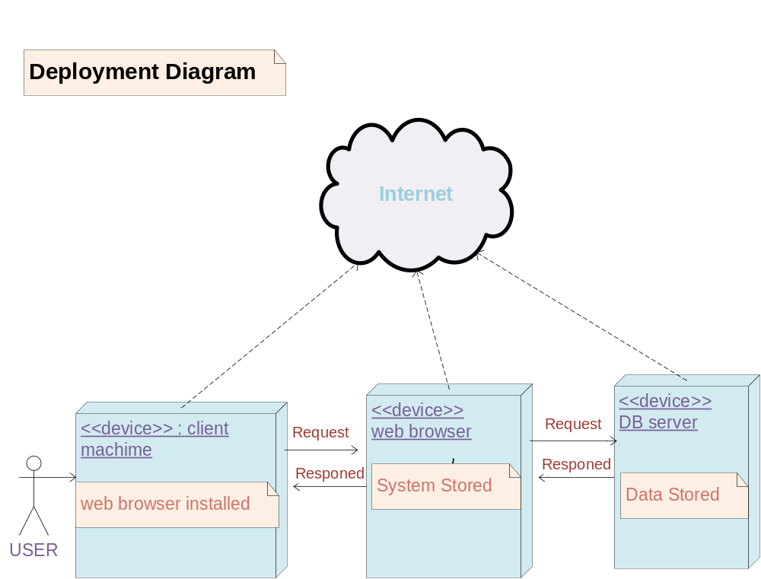figure4.5 deployment diagram

4.6 Design Rationale
The design of the MAU Online Distance Education Management System is based on the requirements of accessibility, security, and data integrity. The following justifications outline the reasoning for the chosen architectural patterns and technologies.

1. Adoption of Layered (3-Tier) Architecture
- Rationale: By separating the Presentation, Business Logic, and Data Access layers, we achieve "Separation of Concerns."
- Benefit: This allows the university to update the User Interface (e.g., moving from a web-based Wix site to a dedicated mobile app) without needing to rewrite the core grading or enrollment logic. It also simplifies troubleshooting by isolating errors to specific layers.

2. Hybrid Data Storage Strategy
- Rationale: The system uses a Relational Database (RDBMS) for structured academic records and Object/File Storage (S3) for multimedia content.
- Benefit: Structured data (student IDs, grades, course codes) requires strict consistency and complex relationships, which RDBMS handles best. However, storing large video files or PDFs directly in a database causes performance lag. Offloading these to file storage keeps the database lean and fast.

3. Security and Defense-in-Depth
- Rationale: Security is integrated at multiple levels rather than just the login screen.
➢Password Hashing: Passwords are never stored in plain text; they are transformed using cryptographic hashes (e.g., SHA-256).
➢Input Validation: To prevent SQL Injection, all user inputs from the web forms are sanitized before reaching the Data Access Layer.
- Benefit: This protects the university’s reputation and student privacy even in the event of a partial system breach.

4. State-Driven Enrollment Logic
- Rationale: The system uses a State Transition model to manage student registration.
- Benefit: This ensures that a student cannot gain access to course materials until their state changes from "Pending" to "Approved" (after payment verification). It automates the enforcement of university policy, reducing the workload on the Registrar's office.

5. Use of Socket Programming for Voting
- Rationale: For the university voting module, a client-server architecture using Java Sockets was chosen.
- Benefit: Sockets provide a direct, low-latency connection between the client and the server, ensuring that votes are cast and recorded in real-time with high reliability.

Summary Table of Design Decisions
Design Goal | Selected Strategy | Justification
Reliability | Normalization (3NF) | Eliminates data redundancy and ensures consistent grade reports.
Performance | File Offloading | Keeps the system responsive during high-traffic exam periods.
Flexibility | Modular Design | Allows for future integration with other university modules (e.g., Library System).

Unit 5. DATA DESIGN

5.1. Data Description
The data design for the Mekdela Amba University Online Distance Education Management System is centered around a Relational Database Management System (RDBMS). This choice ensures data integrity, supports complex relationships between academic entities, and allows for robust transaction management.
- Persistence Policy: All critical academic data (grades, enrollment status, student profiles) are stored in a persistent SQL database. Non-structured or large binary data, such as course module PDFs and instructional videos, are stored in a File Storage System (e.g., Amazon S3 or a local NAS) with file paths maintained in the database.
- Data Integrity: Constraints such as primary keys, foreign keys, and unique indices are enforced at the database level to prevent orphaned records (e.g., an enrollment without a student) or duplicate entries.
- Security: Sensitive information, particularly user passwords, is never stored in plain text. Instead, the system uses industry-standard hashing algorithms (e.g., Argon2 or BCrypt). Data at rest is encrypted to protect against physical server breaches.

5.2 Data Dictionary
This section provides a detailed alphabetical listing of the system entities and objects, integrating the Object-Oriented (OO) descriptions and parameters established in the architectural design.

I. Object & Entity Dictionary
Based on the OO description in Section 4.2, the following table details the attributes and methods for each major system object.
Object / Entity | Attributes | Methods & Parameters | Description
Assessment | assessmentID (int), courseCode (string), type (enum), totalMarks (float), deadline (datetime) | postQuestions(fileContent), calculateResult(studentID, score), notifyStudent(studentID, message) | Represents an exam, quiz, or assignment linked to a specific course.
Course | courseCode (string), title (string), creditHours (int), deptID (int) | addModule(moduleData), assignInstructor(instructorID), getSyllabus() | The academic unit containing instructional materials and assigned staff.
Enrollment | enrollmentID (int), studentID (int), courseCode (string), semester (string), status (enum) | validateEligibility(studentID), confirmRegistration(), updateStatus(newStatus) | The relational entity managing the link between a student and a specific course instance.
Grade_Record | recordID (int), enrollmentID (int), assessmentID (int), score (float) | updateGPA(studentID), generateTranscript(studentID), verifyScore(recordID) | Stores individual marks earned by students for specific assessments.
User | userID (int), fullName (string), email (string), passwordHash (string), role (int) | login(email, password), logout(), updateProfile(data), resetPassword(email) | The base entity for all actors (Student, Instructor, Registrar) in the system.

II. Database Schema
The system uses a normalized relational schema to ensure data consistency.
Table Name | Attributes (Fields) | Primary Key (PK) | Foreign Key (FK)
User | UserID, FullName, Email, PasswordHash, RoleID | UserID | RoleID
Course | CourseCode, Title, CreditHours, DeptID | CourseCode | DeptID
Enrollment | EnrollmentID, StudentID, CourseCode, Semester, Status | EnrollmentID | StudentID, CourseCode
Assessment | AssessmentID, CourseCode, Type, TotalMarks, Deadline | AssessmentID | CourseCode
Grade | RecordID, EnrollmentID, AssessmentID, Score | RecordID | EnrollmentID, AssessmentID

Data Flow
The data flow within the system follows these primary transformations:
- Input Data: User credentials, registration requests, and assignment file uploads (sent via HTTPS).
- Processing: The Application Layer validates business rules (e.g., checking if a student is eligible to enroll) and hashes passwords.
- Storage: Structured data is committed to the RDBMS, while binary files (videos/PDFs) are pushed to the File Storage Service.
- Output Data: Generated transcripts, course lists, and automated email notifications sent to users.
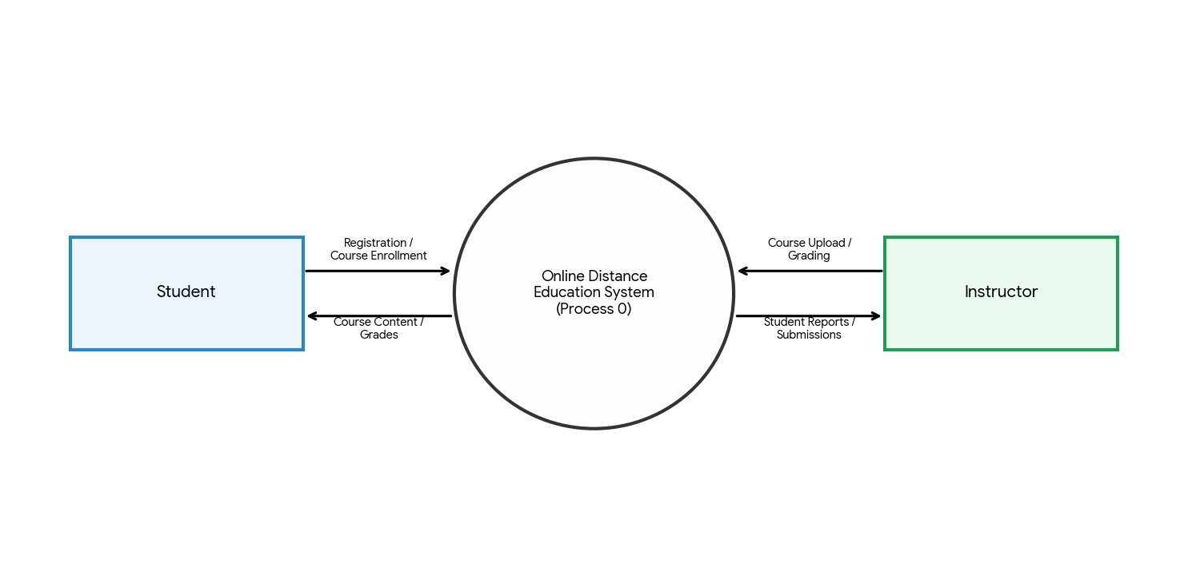

Figure 5.1 Data Flow diagram

Entity-Relationship Diagram (ERD)
The ERD (illustrated in the previous section) defines the following cardinalities:
- User to Enrollment: 1:M (One student can have many enrollments).
- Course to Enrollment: 1:M (One course can have many students enrolled).
- Course to Assessment: 1:M (One course can have multiple assignments/exams).
- Enrollment to Grade_Record: 1:M (One enrollment results in multiple assessment scores).

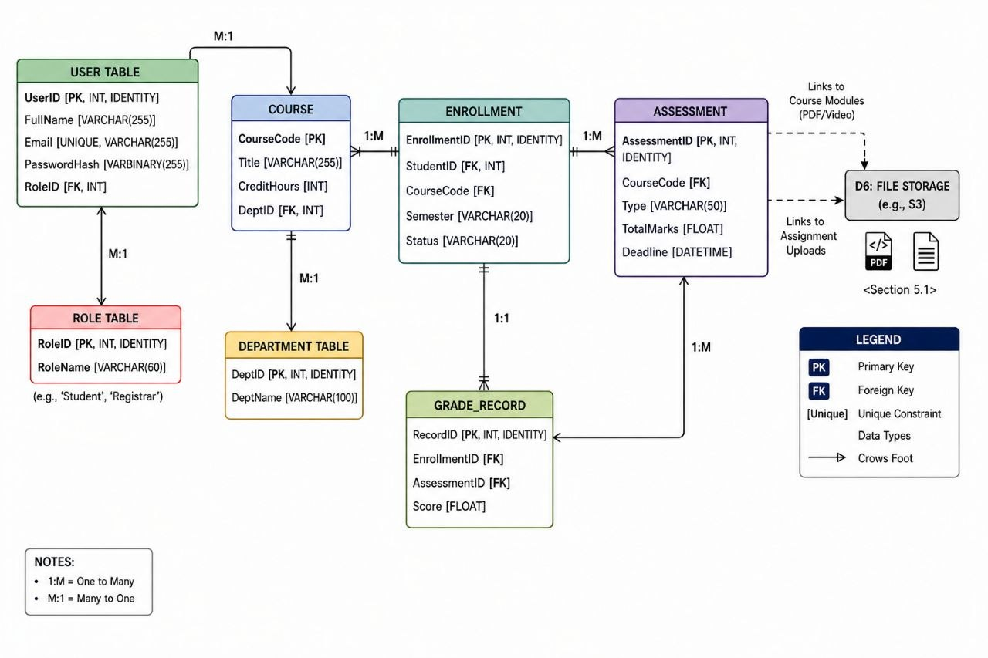
Figure5.2 ERDIAGRAM
Unit 6:component desgin
In this section, we take a closer look at what each component does in a more systematic way. Based on the Object-Oriented (OO) description, the following is a summary of the member functions for the core objects, described in Procedural Description Language (PDL).

6.1 Use Case Diagram
The Use Case Diagram for the MAU CDE MGT System defines the scope of the system by identifying the external actors and the specific functionalities (use cases) they interact with. It serves as a blueprint for what the system must do to satisfy user requirements.

User Object Logic
The User object manages access control and session security for all actors at Mekdela Amba University.
- Method: Login/Authenticate
➢Local Data: input_username, input_password, db_hash, account_status.
➢Logic Flow:
    - Receive credentials from the user interface.
    - Retrieve the matching record and the stored password hash from the database.
    - Check if the account is currently active.
    - Compare the provided password hash with the stored hash.
    - If they match and the account is active, generate a secure session and grant access; otherwise, display a specific error message and log the failed attempt.

Student Object Logic
This component handles student-specific interactions, such as retrieving academic results and accessing materials.
- Method: View Result
➢Local Data: student_id, module_id, result_record.
➢Logic Flow:
    - Identify the logged-in student's ID.
    - Search the Grades table for a record that matches both the student's ID and the selected module.
    - Check if the instructor has toggled the "Publish" status for the grade.
    - If published, display the score and instructor feedback to the user; otherwise, notify the student that results are pending.

Instructor Object Logic
This component enables instructors to manage course content and evaluate performance.
- Method: Upload Learning Material
➢Local Data: file_metadata, storage_path, upload_status.
➢Logic Flow:
    - The instructor selects a file and a target module.
    - The system validates the file format (e.g., PDF, PPT) and size.
    - The system saves the physical file to a secure directory on the university server.
    - The system creates a database entry containing the file name, upload date, and a pointer (URL) to the file location.
    - Confirm successful upload to the instructor and update the module material list.

Academic Dean Object Logic
This component allows for high-level administrative oversight and organizational control.
- Method: Assign Instructor
➢Local Data: instructor_id, module_id, assignment_confirmation.
Logic Flow:
    - The Dean selects an instructor and a course module from the administrative dashboard.
    - The system verifies that the instructor exists and is active.
    - The system updates the Course_Modules table to link that instructor to the specific module.
    - The system logs this administrative change for the registrar's audit trail and notifies the instructor of the new assignment.

Local Data and Interface Description
- Local Data: These are temporary variables (such as status flags, loop counters, and temporary file paths) that exist only during the execution of a specific function. They ensure that data is processed in isolation before being committed to the permanent database.
- Interface: Each object communicates via a strictly defined interface (Input/Output). For example, the Student Object interface requires a ModuleID to return a ResultString. This modularity allows individual components to be updated without breaking the rest of the system.

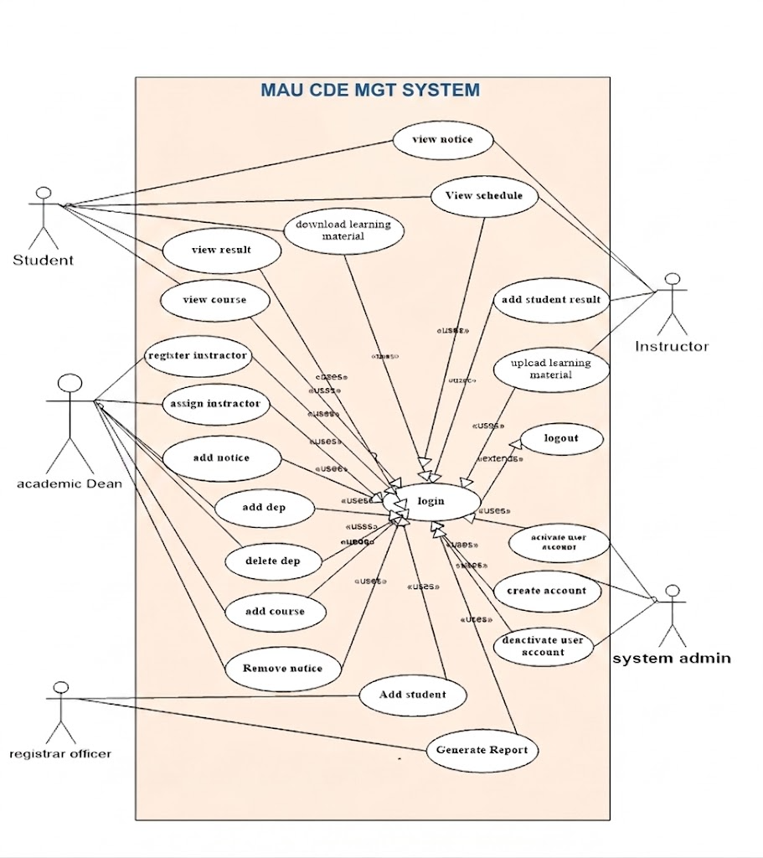
Figure 6.1 Usecase diagram

6.2 Deployment Diagram
The Deployment Diagram illustrates the physical configuration of the hardware (nodes) and the software components that reside on them. This view is essential for understanding how the MAU CDE MGT System is distributed across the university's infrastructure to ensure security, performance, and availability.
The physical deployment of the system is already illustrated in Section 4.5. This diagram shows the mapping of software components to their respective hardware nodes. In this section, we emphasize the specific execution environments for each node.

6.2.1 Node-Level Description
Based on the illustrated deployment view, the system is organized into the following execution environments:
- Client Machine (The User Node):
➢Components: This node represents the hardware (PC, Laptop, or Smartphone) used by students and staff.
➢Execution Environment: As shown in the diagram, it requires a Web Browser installed.
➢Role: It acts as the presentation layer, capturing user inputs and displaying the system’s interface. It is connected to the central system via the Internet.
- Web Browser Server (The Application Node):
➢Components: This represents the central application server (System Stored) where the core software logic resides.
➢Execution Environment: Hosted on a Java-based web server (e.g., Apache Tomcat) to process incoming requests.
➢Role: It receives a Request from the client machine, executes the necessary business rules (such as validating a login or fetching a course module), and sends back a Response.
- DB Server (The Data Node):
➢Components: A dedicated server for the Relational Database Management System (Data Stored).
➢Execution Environment: MySQL or PostgreSQL server engine.
Role: It manages the persistence of academic records. It interacts with the application server to store or retrieve data related to students, courses, and grades.

6.2.2 Communication and Interaction Logic
- Request-Response Cycle: The diagram depicts a clear interaction flow. The Client Machine initiates a request through the internet; the Application Server processes this request by communicating with the DB Server, and finally, the processed data is sent back to the user as a response.
- Security & Accessibility: By deploying the System Logic and Data Storage on separate server nodes, Mekdela Amba University ensures that sensitive academic data is protected from direct external access while remaining available to authorized users over the web.

6.3 Environment Description
The Environment Description defines the technical ecosystem required to support the MAU CDE MGT System. These requirements ensure that the hardware and software are capable of handling concurrent users, secure data storage, and the delivery of large learning materials.

➢ Servers
To ensure high availability and performance, the system is hosted on a dedicated server infrastructure within the university data center.
- Application Server:
➢CPU: Quad-Core Processor (3.0 GHz or higher).
➢RAM: 16 GB minimum (to handle concurrent student sessions).
➢Storage: 500 GB SSD (for fast application execution and temporary logs).
- Database Server:
➢CPU: Octa-Core Processor.
➢RAM: 32 GB (to optimize query processing and indexing).
➢Storage: 1 TB RAID 10 configuration (for redundancy and data safety).
- Storage Server (NAS):
➢Capacity: 2 TB+ Scalable storage dedicated to hosting PDF modules and lecture videos.

➢ Databases
The data tier manages the persistent records of the distance education center.
- Primary Database: MySQL 8.0 or PostgreSQL 15 (Relational database management system).
- Justification: Relational databases are required to maintain strict integrity between students, their enrolled courses, and their final grades.
- Backup System: Automated daily incremental backups to an off-site server or secure cloud storage.

➢ Operating Systems (OS)
The choice of OS focuses on security and stability for server-side operations and compatibility for users.
- Server-Side OS: Ubuntu Server 22.04 LTS or Red Hat Enterprise Linux (RHEL). These provide a secure, command-line environment optimized for Java-based application hosting.
- Client-Side (User) OS:
➢Desktop: Windows 10/11, macOS, or Linux.
➢Mobile: Android 10.0+ or iOS 15+.
➢Software Requirement: A modern web browser (Chrome, Firefox, or Safari) with JavaScript enabled.

➢ Network Configuration
The network must facilitate secure and fast communication between the university and its remote students.
- Connectivity: High-speed internet backbone (minimum 100 Mbps uplink).
- Protocols:
➢HTTPS: All traffic must be encrypted using SSL/TLS certificates.
➢TCP/IP: Standard communication protocol for web traffic.
- Security Configuration:
➢Firewall: Configured to block all ports except 80 (HTTP), 443 (HTTPS), and 22 (SSH for admin).
➢Subnets: The Database server is placed in a Private Subnet, meaning it cannot be reached directly from the internet; it only talks to the Application Server.
➢Load Balancing: (Optional) To distribute traffic across multiple servers during peak exam periods.

Unit 7: REQUIREMENTS MATRIX
The Requirements Matrix ensures that every functional requirement identified in the Software Requirements Specification (SRS) is addressed by a specific component or data structure in this design. This traceability guarantees that the system fulfills its intended purpose.
SRS Req. ID | Functional Requirement | System Component | Data Structures (Tables)
FR-01 | User Authentication | User Object / Login Logic | Users, Roles
FR-02 | Student Registration | System Admin Object | Users, Students
FR-03 | Course Management | Academic Dean Object | Course_Modules, Departments
FR-04 | Material Upload | Instructor Object | Materials, Course_Modules
FR-05 | Material Download | Student Object | Materials
FR-06 | Assignment Submission | Student Object | Assignments, Submissions
FR-07 | Grade Management | Instructor Object | Grades, Submissions
FR-08 | Result Viewing | Student Object | Grades
FR-09 | Report Generation | Registrar Officer Object | Students, Enrollments, Grades
FR-10 | Account Management | System Admin Object | Users, Audit_Logs

Design Decisions
This section records the critical architectural choices made during the design phase of the MAU CDE MGT System.

1. Architectural Pattern: 3-Tier Architecture
- Alternatives Considered: Monolithic Architecture.
- Trade-offs: 3-tier is more complex to set up initially and requires more server resources compared to a monolith.
- Justification: Given that Mekdela Amba University expects a high volume of remote students, the 3-tier approach allows us to scale the Database and Application layers independently. It also provides superior security by hiding the database behind a private subnet.

2. Database Selection: Relational (MySQL/PostgreSQL) over NoSQL
- Alternatives Considered: MongoDB (NoSQL).
- Trade-offs: NoSQL offers faster writes and flexible schemas, but lacks strict ACID compliance.
- Justification: Academic records (grades and registrations) require absolute data integrity and complex relationships. Relational databases ensure that a grade cannot exist without a student and a course, preventing "orphan" data.

3. Storage Strategy: File Server for Large Assets
- Alternatives Considered: Storing PDFs and Videos as BLOBs (Binary Large Objects) directly in the Database.
- Trade-offs: Storing files in the DB makes backups easier (one file), but significantly slows down database performance and increases backup size.
- Justification: To maintain a fast system response time, large files are stored on a dedicated file server, with only the "path" or link stored in the database. This keeps the database lean and fast.

4. Client Interface: Web-Based (Browser) over Native Desktop App
- Alternatives Considered: Developing a dedicated Java Desktop Application.
- Trade-offs: Desktop apps can have better offline features but require manual installation and updates on every student's computer.
- Justification: A web-based interface ensures the system is "platform-independent." Students can access the MAU portal from any device (Phone, Tablet, or PC) without installing software, which is critical for a distance education environment.

UNIT 8: CONCLUSION
The Software Design Document (SDD) for the Online Distance Education Management System establishes a rigorous technical foundation for the modernization of academic delivery at Mekdela Amba University. By transitioning from fragmented records to a centralized, layered architectural framework, the system effectively bridges the physical gap between the institution and its remote student population.
The design strategies detailed in this document—ranging from high-level architectural patterns to granular component logic—ensure that the platform is not only functional but also resilient, secure, and highly maintainable. The selection of a 4-Layered Client-Server Architecture specifically addresses the university's need for data integrity while providing the flexibility to adapt to future technological advancements.
Key outcomes achieved through this design include:
- Architectural Clarity: A clear separation of concerns that allows for independent updates to the user interface and database layers.
- Robust Data Integrity: A normalized relational schema that ensures "a single version of truth" for all student and course records.
- Quality Assurance: Explicit tactics for availability, security, and performance that guarantee a stable user experience even during peak academic periods.

